Architecture/Infrastructure Design
Define the architecture of the system
Neuromend is simulation software for user interaction and manipulation of objects in a virtual world. It will be installed onto PC systems and work with several sensory devices in order to achieve this. Neuromend will be a fairly small program containing just three levels for users to play through. User performance will be tracked and stored onto a sever containing a database, which will be accessible anywhere with internet connectivity. There will be four versions of Neuromend, each supporting a specific device combination.

Provide an architectural diagram if applicable (this can include the structure of static web pages, a guide to navigation).
The diagram below is an example of how the system’s architecture will look like.
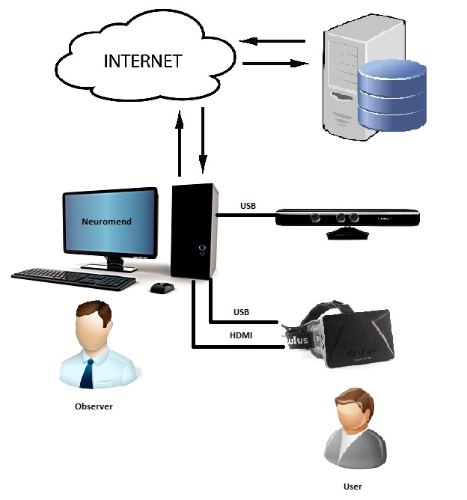
Figure 1.1 – Architecture example using Oculus Rift + Kinect combination [1].

Additional software components as necessary
In order for the architecture to be operational some outside software is required. These include the drivers for the sensory devices and their associated software development kits (SDK). The architecture makes heavy use of the SDKs provided with the sensory devices so they must exist on the system that will run Neuromend. All of this outside software will be included in the package.

Infrastructure requirements:
Capacity
The system will work with one user at a time. It will have a user put on the Oculus Rift and operate their desired sensory device or mouse and keyboard. The sensory devices include Kinect for Windows, Leap Motion and Razar Hydra. The program will have output shown on a monitor so others can observe what a user is doing. Installation of Neuromend needs to be done before operating the program so some available hard disk drive space will be required. Transactions will occur between the system running Neuromend and a server so a stable internet connection will also be required. These transactions involve sending and receiving users’ performance data.

Performance
Systems that will run Neuromend will need to be relatively modern in order to smoothly display its graphics. This is important because slow/jerkiness will be disorientating for users, which will negatively impact their performances because their speed of each level completion is timed.

Integration & compatibility
As mentioned in the performance section the system that will run Neuromend will need to be relatively modern. It will require a decent graphics card, internet connectivity, available hard disk space and USB ports. Compatibility between the sensory devices is required for operation. Systems will need compatibility with the following sensory device combinations Oculus Rift + Razer Hydra, Oculus Rift + Leap Motion, Oculus Rift + Kinect or a keyboard and mouse.

Platform strategy
Systems will need to have Windows 7 to run Neuromend. Support and compatibility cannot be guaranteed on other versions of Windows or Macs because of the developmental nature of the sensory devices.

Security
Neuromend will require users to input some personal data about themselves in order to accurately track their performances. This data will be stored on the system running Neuromend and a server communicated with through an internet connection. To make such data unidentifiable if there ever is a breach users’ will be identified using a unique ID instead of by names. Data stored in the database will be protected and have restricted access to those who have the right permissions. Access will be done through a log in system as a form of authentication.

Back-up & recovery
Local failure on a system running Neuromend will not be a big issue because user data will still be stored on a sever so a recovery can be performed by getting lost user data back onto the system once it’s running again. However, there is a chance that the server may fail so local backs-up should continually be made by users. This should involve copying data over to external storage in case both their system and the server fail at the same time.

Scalability
Design of Neuromend focuses on separation of functionality so it can be scaled up easily if required. This may include a multiplayer option so more than one user can play Neuromend at a time. It may also include using additional devices for finer control.

Future proofing
The sensory devices developmental nature means that they will likely change quickly with time. Neuromend is not designed not to force users to upgrade devices should new ones become available. Updating of sensory devices may require patches for Neuromend to work with any new SDKs that accompany such devices.

Discuss alternative designs
An alternative of designing four separate versions of Neuromend is to design just a single one that contains options in the software itself to switch between device combinations. However, this would prove fairly difficult because it was discovered early on that some of the sensory device drivers’ conflict with each other. This could cause system failures or device inoperability.

[1] References
http://www.rockwellautomation.com/resources/images/rockwellautomation/services/Generic_Computer--graphic_280w.jpg
http://www.dallmeier.ru/fileadmin/upload_electronic/Unternehmen/Niederlassungen/Dallmeier_Russland/Planning_icons_single/Shapes/JPG/Symbols/Cloud%20internet.jpg
http://www.advess.net/media/database_server1.jpg
http://www.blograzzi.net/wp-content/uploads/2011/04/arrow.jpg?234d14
http://www.tedesys.es/sites/default/files/kinect.jpg
http://upload.wikimedia.org/wikipedia/commons/a/ae/Oculus_Rift_-_Developer_Version_-_Front.jpg
http://www.softicons.com/social-media-icons/free-social-media-icons-by-aha-soft/user-icon
http://www.softicons.com/web-icons/user-icons-by-2shi/user-1-icon

